~Network Troubleshooting, Management, monitoring, and Optimization:
- Use the Windows command prompt to run the command ipconfig /all on your computer and take a screenshot of the output. Identify and write down your IPv4 address, subnet mask, default gateway, and DNS servers as shown in the result.

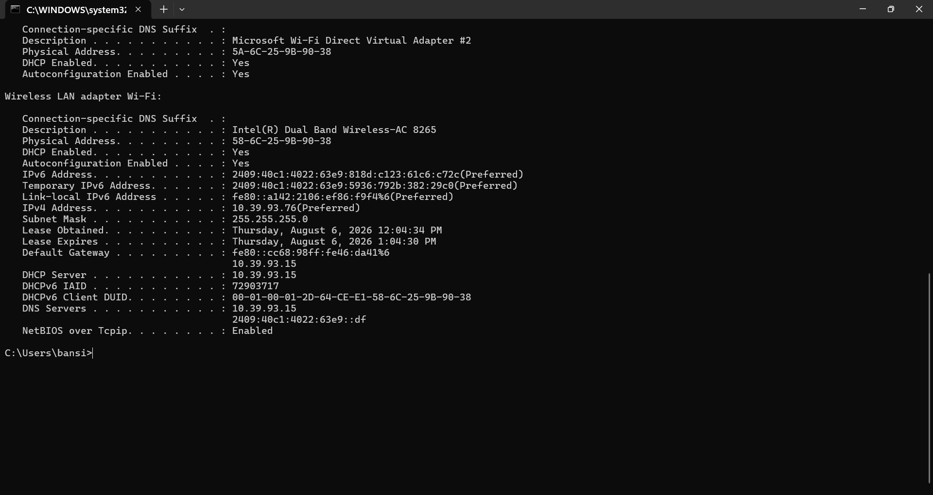

Record of my ipconfig on laptop:
Parameter | Value
IPv4 Address | 10.39.93.76
Subnet Mask | 255.255.255.0
Default Gateway | 10.39.93.15
DNS Server (Primary) | 10.39.93.15
DNS Server (Secondary - IPv6) | 2409:40c1:4022:63e9::df

- Simulate a network connectivity issue by disconnecting your Wi-Fi or Ethernet cable, then use the ping command to check connectivity to www.google.com. Reconnect and repeat the ping. Write a short note on the difference in results and what each status means.

When Wi-Fi/Ethernet is Disconnected:
“Ping request could not find host www.google.com. Please check the name and try again.”

When Wi-Fi/Ethernet is Reconnected:
Pinging www.google.com [2001:4860:482a:7700::] with 32 bytes of data:
Reply from 2001:4860:482a:7700::: time=36ms
Reply from 2001:4860:482a:7700::: time=28ms
Reply from 2001:4860:482a:7700::: time=32ms
Reply from 2001:4860:482a:7700::: time=56ms

Ping statistics for 2001:4860:482a:7700:::
Packets: Sent = 4, Received = 4, Lost = 0 (0% loss),
Approximate round trip times in milli-seconds:
Minimum = 28ms, Maximum = 56ms, Average = 38ms

Short Note (Line by Line):
- Disconnected: Ping failed because there was no network connection.
- Status: "Request timed out" – The computer did not receive a reply from the destination.
- Reconnected: Ping was successful after the Internet connection was restored.
- Status: "Reply from..." – The destination server responded successfully.
- Conclusion: The network was working properly after reconnecting to Wi-Fi/Ethernet.

- Open Task Manager or Resource Monitor on your system and monitor network usage for 5 minutes while streaming a YouTube video. Record the peak network usage value and note which process used the most bandwidth during this time.

Recorded result:
Parameter | Sample Value
Duration- | 5 minutes
Peak Network Usage- | 8.5 Mbps
Process Using Most Bandwidth- | Google Chrome (YouTube)

Short Note:
During YouTube streaming, the browser process used the highest bandwidth because it continuously downloaded video data. Network usage increased while the video was buffering and remained steady during playback..

- Download and install Wireshark (or use an online packet capture demo if installation is not possible). Capture at least 30 seconds of network traffic while browsing Flipkart or Instagram Web, then filter the packets to show only HTTP or HTTPS traffic. List 3 types of information you can see in these filtered packets.<br><br><em><strong>Hint:</strong> Use the filter bar in Wireshark and try http or https as the filter keyword.</em>
Steps:
- Install and open Wireshark.
- Select your Wi-Fi or Ethernet interface.
- Click Start Capture.
- Browse Flipkart or Instagram Web for 30 seconds.
- Click Stop Capture.
- In the Filter bar, type:
  - http (for HTTP traffic), or
  - tls (for HTTPS traffic, since HTTPS is encrypted and appears as TLS in Wireshark).
- Press Enter to apply the filter.

Three Types of Information You Can See:
Information | Description
Source and Destination IP Address | Shows which device sent the packet and which server received it.
Protocol (HTTP/TLS) | Indicates whether the traffic is standard HTTP or encrypted HTTPS (TLS).
Packet Size and Time | Shows the size of each packet and the timestamp when it was captured.

Short Note:
Filtering packets helps you analyze only the web traffic of interest. For websites like Flipkart and Instagram, most traffic appears as TLS (HTTPS) because the data is encrypted for security.

- Imagine your friend is complaining about slow internet while gaming online. Use ChatGPT or any AI tool to generate a troubleshooting checklist (at least 5 points) for optimizing home network speed and reliability. Paste the AI's response and highlight one suggestion you would try first.
AI-Generated Troubleshooting Checklist for Slow Internet While Gaming
- Restart the Wi-Fi router and modem to refresh the network connection.
- Use a wired Ethernet connection instead of Wi-Fi for lower latency and a more stable connection.
- Close background downloads and streaming apps that consume bandwidth.
- Place the router in a central location and reduce interference from walls or other electronic devices.
- Update the router's firmware and the network adapter drivers to improve performance.
- Limit the number of devices connected to the network while gaming.
- Run a speed test and contact your ISP if the internet speed is much lower than your subscribed plan.
Suggestion I Would Try First
✔ Restart the Wi-Fi router and modem, as this often resolves temporary network issues and improves connection stability.
THE END…….

